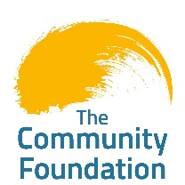
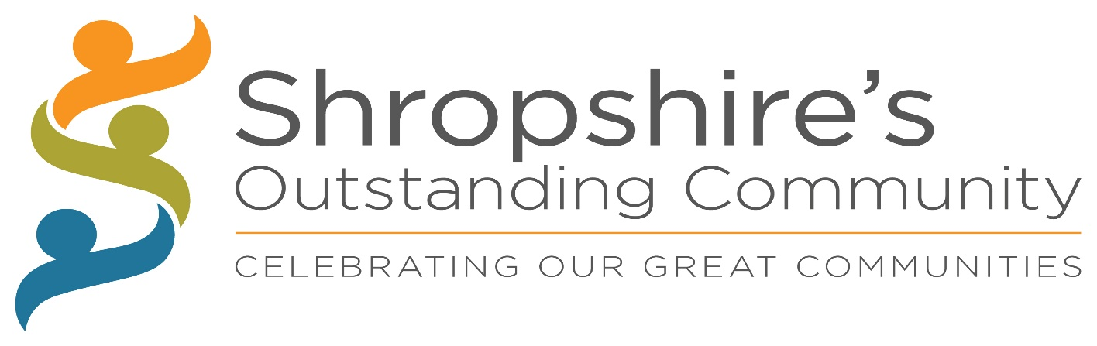
Shropshire’s Outstanding Community 2022 Shropshire is known as one of England’s most rural and arguably least discovered, yet beautiful, counties. With no cities, it comprises of 22 towns and hundreds of villages and hamlets. Its historical role as the birthplace of the Industrial Revolution is still apparent with an enterprising and entrepreneurial spirit, plus a strong sense of community identity which helps define our county.
Divided into two distinct halves, The North Shropshire Plain has Shropshire’s largest towns and population, whilst South and West Shropshire is dominated by hills, woodland and river valleys, and home to villages and more sparsely populated areas. Administratively, ‘ceremonial’ Shropshire has two local authorities: Shropshire Council and the Borough of Telford and Wrekin. Shropshire Council looks after just under 92% of the land area of ceremonial Shropshire including the county town of Shrewsbury whilst Telford, an original ‘New Town’, was created over fifty years ago by merging a number of smaller towns and is now the largest town in the county and is one of the fastest growing towns in the UK as a beacon of technology, innovation and light industry.
Shropshire’s Outstanding Community wants to offer all communities within the ceremonial county the opportunity to be recognised and celebrate the strong, supportive community spirit, whether it’s a community within a town, a village or even a street or housing development. We want to shine a light where people come together and support each other, where people have developed a safe and thriving environment in which to live.
Plenty of great things go on within our communities which does not always get duly recognised. ‘Community’ is a term that can be used very broadly. In this context it is not about aesthetics -gardens, borders, and flowers! It is more about relationships, bonds, identity and where people have come together with a collective investment in their neighbourhood, where attitudes and interest are commonly shared.
We encourage people who take pride in their community, both rurally and within our towns, to come forward and showcase what they have achieved. It is an opportunity to tell us about the great things that are going on within your community and celebrate why it’s great to live in Shropshire.
The categories are:
Small Village
Large Village
Town
Community Group/Organisation

SPONSORS LOGOS
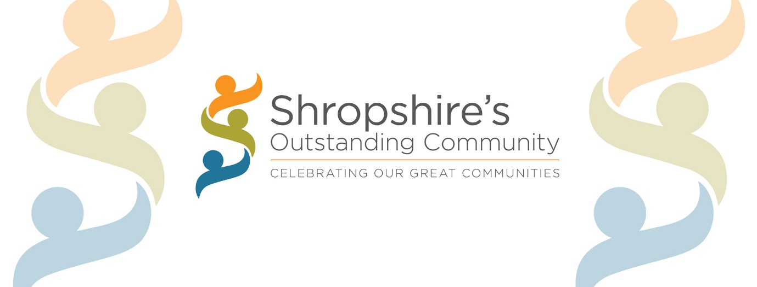

ENTRY FORM

PLEASE COMPLETE IN BLOCK CAPITALS AND RETURN TO:

shropshire@outstanding.community
or
The Community Foundation, , Communications House, University Court, Staffordshire Technology Park, Stafford, ST18 0ES

NO LATER THAN THE 30th June 2022
NAME OF REPRESENTATIVE:
EMAIL ADDRESS:
TEL NO: ………………………………………

NAME OF COMMUNITY: …………………………………………………….
NAME OF ORGANISING GROUP: ……………………………………………………….
CATEGORY
DETAILS OF CORRESPONDENT (to whom all communications will be sent)

NAME: ……………………………………. TEL NO: …………………………………….
ADDRESS:

EMAIL:

1. Describe your community and its location (e.g. street, housing estate, village, town, group of houses, block of flats, other)

2. How many people does your community extend to?

3. Facilities in your community (please tick)
NOTE This section has no bearing on the judges scoring but is just for them to be able to contextualise your application.

 | Community buildings |  | Communal areas |  | School |  | Doctors
 | Park/Playing fields |  | Public house |  | Shop |  | Dentist
 | Seats /benches |  | Telephone box |  | Place of worship |  | Toilets
 | Cycle racks |  | Bus shelter |  | Transport links |  | Dial a ride
 | Café |  | Allotments |  | Post box |  | Signage
 | Litter Bins |  | Facebook/  Social Media |  | WhatsApp  group
 | Other (list)
Facebook Link
Website link
YouTube link
Other links

4. Tell us about/what is special about your community
a. Community activities

b. Community initiatives and support

c. Communication and connectivity

d. Health and wellbeing

e. Sustainable/green initiatives

f. Nature

g. Security and safety

h. Physical environment

i. Other

5. Explain the positive impact and outcomes for all groups in your community and how you ensure inclusivity

6. How are members of your community given the opportunity to voice their concerns, suggestions and aspirations for the community

7. Why do you consider your community to be outstanding (in less than 200 words)?

7. Please submit a map of your community with key points marked (tick to confirm submitted) [ ]
8. Please submit evidence in support of your application (e.g. photos, video clips, testimonials, press articles etc)
Please list what you have attached/submitted.

9. Do you have any plans for the coming year in your community? (in less than 200 words) (NOTE This section is optional and has no bearing on the judges scoring)

10. ????

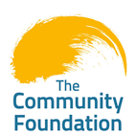
CONSENT
By completing this form, you give The Community Foundation permission to keep your details securely on our database and use them for communication purposes.

Name

Address
Postcode
Contact name.

Contact telephone number.

Contact email address.

By ticking this box, you confirm that parental permission has been sought to submit photographs where children and young people, under the age of 18, are included.

By ticking this box, you give consent for any photographs and supporting evidence submitted to be used for promotional purposes and can be shared on The Community Foundation social media platforms and website.

